Other-Letter; A hybrid of Sinhala and Tamil script for Sri Lanka

-A Work in Progress

Pathum Egodawatta, Graphic Designer, pathumego@gmail.com

**Abstract**: This paper documents and discusses a development process of a new script based on Sinhala and Tamil scripts. Sri Lanka has been in a civil war for more than 30 years and ethnic tension between the Sinhalese majority and the Tamils, the largest minority in the island is still rising after the war. Main reason for the ethnic conflict is identified as the language. A deeper look into the visual properties of the two alphabets, and their development prompted the possibility of constructing a single script and and a writing system, based on Sinhala and Tamil that can be used to write and read both languages. The project scope was to develop a typography based solution to dissolve the language barrier between the Sinhala and Tamil communities and communicate the message of harmony. In addition to the development process of the project, this paper briefly discuss the socio-political background which raised the opportunity for a such script.

***Key words:*** *Hybrid Script, New Script, Ethnic conflict, New Language*

1. **Introduction**

When two or more languages co-exist in a polity why does language become the “Object of social and Political conflict”? (Bohem, 1933) In the case of Sri Lanka the language was the catalyst of the whole conflict, which span for over 30 years and left the country in a tension.

Sinhala and tamil are the two official languages of Sri Lanka. Sinhala is the most widely used language in the country which is used by 74% of the population while Tamil is used by 18% of the population. Tamil community is concentrated at the far northern parts of the the island and along the east coast and some up country areas.

The ethnic conflict in Sri Lanka has been traced back to pre independence era and language has been identified as one of the primary catalyst for the war. The armed conflict and terrorism of LTTE saw an end in 2009 and post-war reconciliation efforts of the government are being heavily criticised. To worsen the situation there is growing distrust between the different ethnicities in the country due to activities of different religious extremist groups. In the post-conflict Sri Lanka the various reconciliation efforts have been carried out and the language factor is something that has been addressed by policy makers, political and social activists, creative community as well.

1. **Understanding the Ethnic conflict and the role of language in it.** 
   1. **Transformation of language conflict to a territory conflict**

The historical relationship between Sinhalese and Tamil communities was not always agnostic. In the pre colonial era, there were clear boundaries that differentiated the two communities such as language and scripts, religion, social organisation, territorial concentration and sense of collective history. But with the introduction of Christianity and English language the symmetry of the ethnicities was disrupted and there were both Sinhala speaking Christians, and Tamil Speaking Christians. But the Sinhala and Tamil identities were not totally abundant because of the Christianity. This new mix of ethnic traits were subjected to the fast growing nationalist movements peace movement. It is obvious that by the time the british left the country the historical ethnic symmetry in the country was disturbed.

Under the Portuguese, Dutch and British colonial ruling that had been the Sinhalese majority came to see them as the subordinate group of the society, politically and in socioeconomic terms(Dharmadasa, 1981, pp. 47-70). With the departure of the British the Sinhalese majority tried to connect with the past greatness of the Sinhalese, the language was brought forward as a main identifier of the ethnicity.

In a Study of North India, Paul Brass argues that,in a certain historical and social context,one ethnic traitor or symbol may be identified as dominant and others as secondary(Brass, 1974). In Sri Lankan context spoken language and the script language is written in, was the dominant symbol among other ethnic traits such as religion.Due to the pressure from the public and as a result of political gameplay in 1956 Official Languages Act was passed making Sinhalese the only official language of Sri Lanka. This is noted as one of the defining incidents of the Sri Lankan ethnic conflict, as this action led the Tamil community to turn to the 'territory' factor. A certain language is used by people, people live in a territory and the sense that language occupies a territory led became the resolution to the language conflict in Sri Lanka.(Dharmadasa, 1981, pp. 47-70)

It is to be noted that there is a historical sense among the Sinhalese of being the subordinate community in the country and the actions taken by the Sinhalese community in response to this feeling, led the Tamils feeling powerless and aneciouxios.

The failure to accommodate the needs and requests of the Tamil community was seen as a discrimination. The Tamil armed youth movement sprung in late 1970’s and with the 1983 Black July riots, the conflict was advanced to a war.

1. **The New Development and Rehabilitation, Need of new social structures**

In year 2009 the war was officially declared over by the government of Sri Lanka with the defeat of the LTTE. SInce the rehabilitation and the reconciliation in the country has been criticized internationally. Despite the efforts of the government the civil society is far from a meaningful harmony. In a survey carried out in November 2013[1] 82.2% of Sinhalese believed that Official Language of Sri Lanka is SInhalese only and 26.5 of Tamils said that Government of Sri Lanka has done nothing to address the root causes of the conflict.

Although the official languages policy was revised with making Tamil a co official language implementation of policies for bilingual access haven't been successful. Report of the COMMISSION OF INQUIRY ON LESSONS LEARNT AND RECONCILIATION reports implications of this.



“..the tardiness of Governments in giving effect to its implementation (of 13th

Amendment to the Constitution in 1987 that made both Sinhala and Tamil official languages ) has further alienated the Tamil people, exacerbating their feelings of marginalization. This has resulted in a perception prevailing among the Tamil people of being second class citizens in their own country.”

(LLRC, 2011)

* 1. **Cultural invasion**

There are accusations of cultural invasion in the areas that has been freed from the LTTE. Northern and eastern parts of the country was under control of LTTE and tamils are the majority in these areas. Most of these areas are still under military control and there have been observations where use of Sinhala language in these areas for essential needs have intimidated the Tamil people. This was noted in the Report of the COMMISSION OF INQUIRY ON LESSONS LEARNT AND RECONCILIATION

* *“The Commission during its visits to the affected areas witnessed firsthand, that even today many persons of the minority communities are made to transact business not in the language of their choice.”* (LLRC, 2011)

* 1. **Change of demographic distribution and Language invasion**

With the controversial resettlement [2] of the displaced SInhalese families in Northern and Eastern parts on the island, now there is a constructed demographic distribution in these areas. This situation has created a greater level of tension between the ethnicities. Construction of new Buddhist temples and establishment of Sinhalese businesses have made the Sinhala letters and boards appear in wide light in middle of theses previously Tamil concentrated areas.

Many businesses and institutions such as banks who started their branches in North recently are using the same advertising and promotional materials which were produced for Sinhala majority audience. (Jayasuriya, 2011) And this is perceived by the Tamil community in this as an invasion of culture and territory.



1. **A hybrid Script of writing**

The opportunity for a typography based solution or an intervention, raised with the ‘appearance of the language’ becoming a vital factor in reconciliation in the Northern and eastern parts of the island. The idea was to develop typography-based solution to dissolve the language barrier between the two races and communicate the message of harmony. The appearance of an alien language is intimidating the communities in North.

* 1. **The Project scope**

The project focus was to combine letters from SInhala and Tamil scripts that has the same pronunciation and construct a new letter that could be read by the both communities. New script could be considered as a new constructed script[3].

Following basic guidelines were established to streamline the process.

1. Both writing systems should be simplified preserving the qualities of both scripts. (ie: Consonant and vowel signifier combination)

2. Characters should be easy to recognize and this should be evaluated based on following aspects.

i. The readability

ii. Preserving the original visual aesthetic qualities of the both languages.

iii. Characters should work together visually as one typeface.

iv. Always test for readability and legibility ( with different demographic segments)

3. Consider the project as one community seeking for a unified writing system.

4. Reference the other scripts from the same family such as Kannada and Malayalam.

5. Preserve the original forms and aesthetics of the letters.

* 1. **Research methodology**

Each glyphs were developed based on the combination of following three methods.

* + 1. **Identifying common and similar visual elements**

There are obvious similarities between the Sinhala and Tamil scripts due to the common roots.[4] The Figure 1 Shows the each The first step was to identify these similarities between the corresponding letters. For the purpose of study FM Malithi [5] and Kohinoor Tamil [6] was used as the reference typefaces for Sinhala and Tamil.

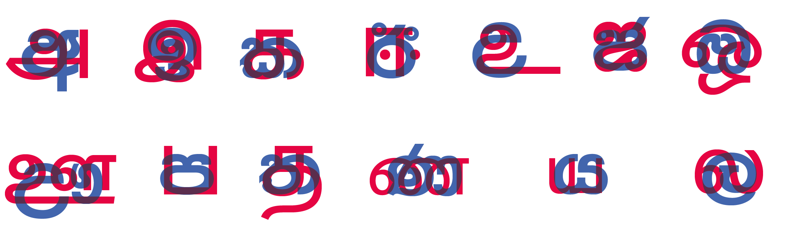

The next step was to identify t

* + 1. **Understanding the basic visual concept of each letter.**

The common roots of the Sinhala and Tamil languages were explored and identified. Each letter is a combination of Sinhala letter with the Tamil letter corresponding to the same sound. The characteristics and aesthetics of both scripts were taken into account and new script/ typeface was developed to be neutral without being bias to a single script.

Sinhala has more than 200 identified loanwords with Tamil origins and many other common words which were borrowed from Portuguese.(Coperahewa and Arunachalam, 2002) Both Sinhala and Tamil scripts belong to the same Brahmic scripts family and few steps back into the development of some characters reveal

* + 1. **Identifying most significant element of each Tamil and Sinhala letter**

Apart from the basic form and shape of a letter, there were significant element to each letter. In some corresponding Sinhala and Tamil letters, this significant elements were the only thing that set apart the two letters. (See the figure X)

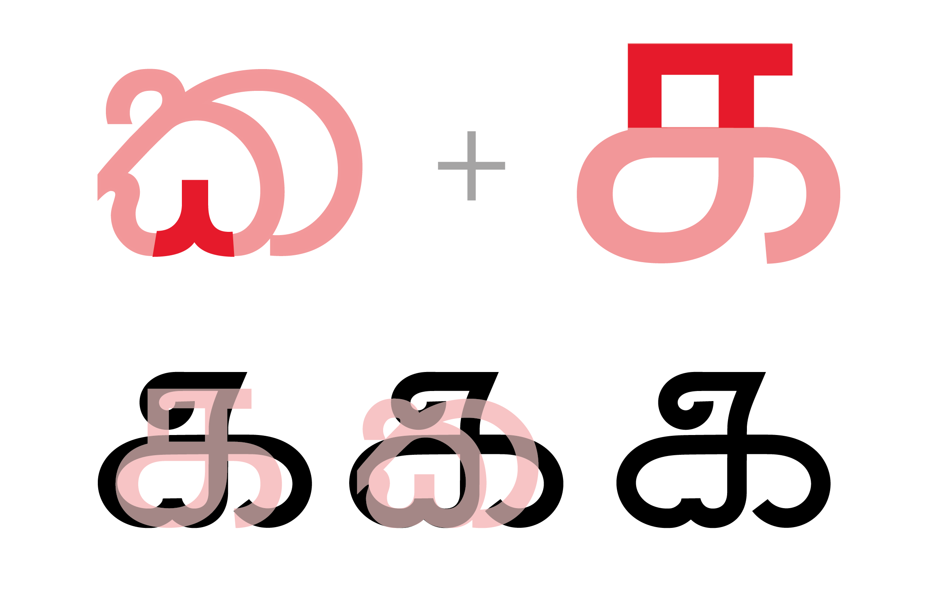

* 1. **Development of the grid**

The new script required a new set of guidelines in order to keep the structural integrity and aesthetic of the characters. In this case the grid system was essential due to the hybrid nature. Unfortunately the lack of literature on the anatomy of Sinhala letters was a downside during this exercise. The baseline, ascender height and the descender height was developed based on two different heights, benchmarked from ‘Font Master Malithi’ font family and ‘Kohinoor Tamil’ font family.

The positioning of the letters were the most crucial element in regard to legibility. It was observed during the user testing that legibility of some letters would dramatically vary based on the positioning. Figure XX illustrates the development of corresponding letter to **phoneme** (r) . Sinhala ‘ර’ is a ascending letter and Tamil ‘ர’ is descending letter. The two letters are almost vertically flipped versions of each other. Due to this difference of position relatively to the baseline, the grid was developed duel lined in the baseline, ascender and descender lines. 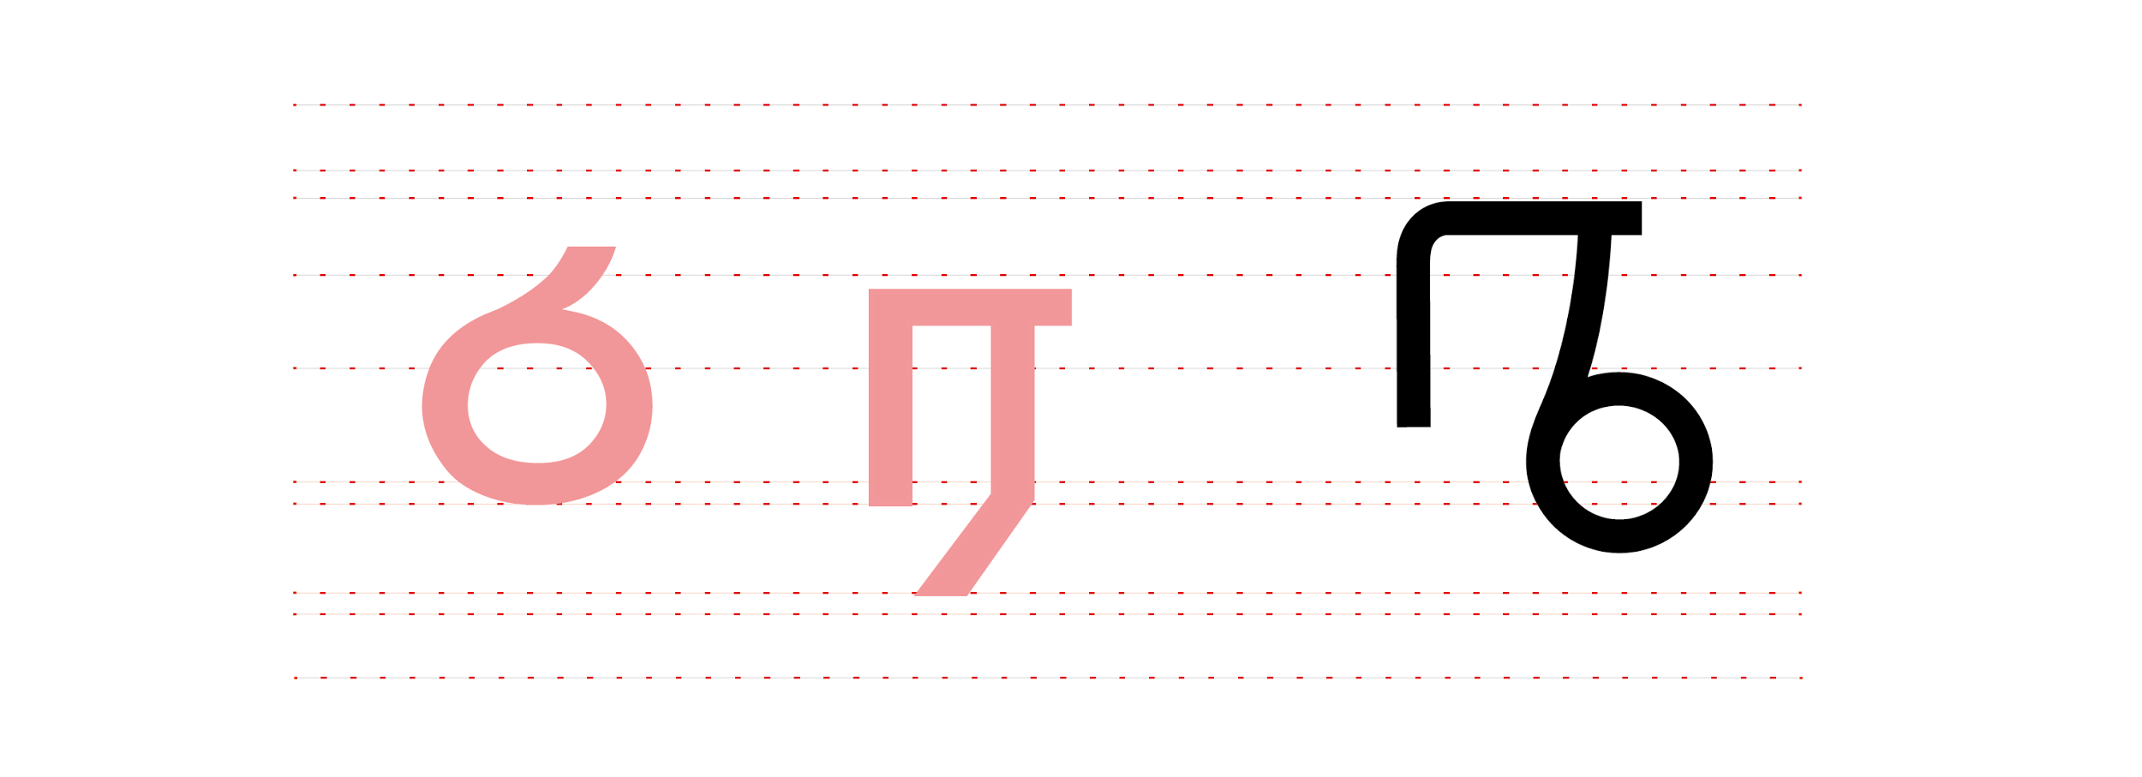

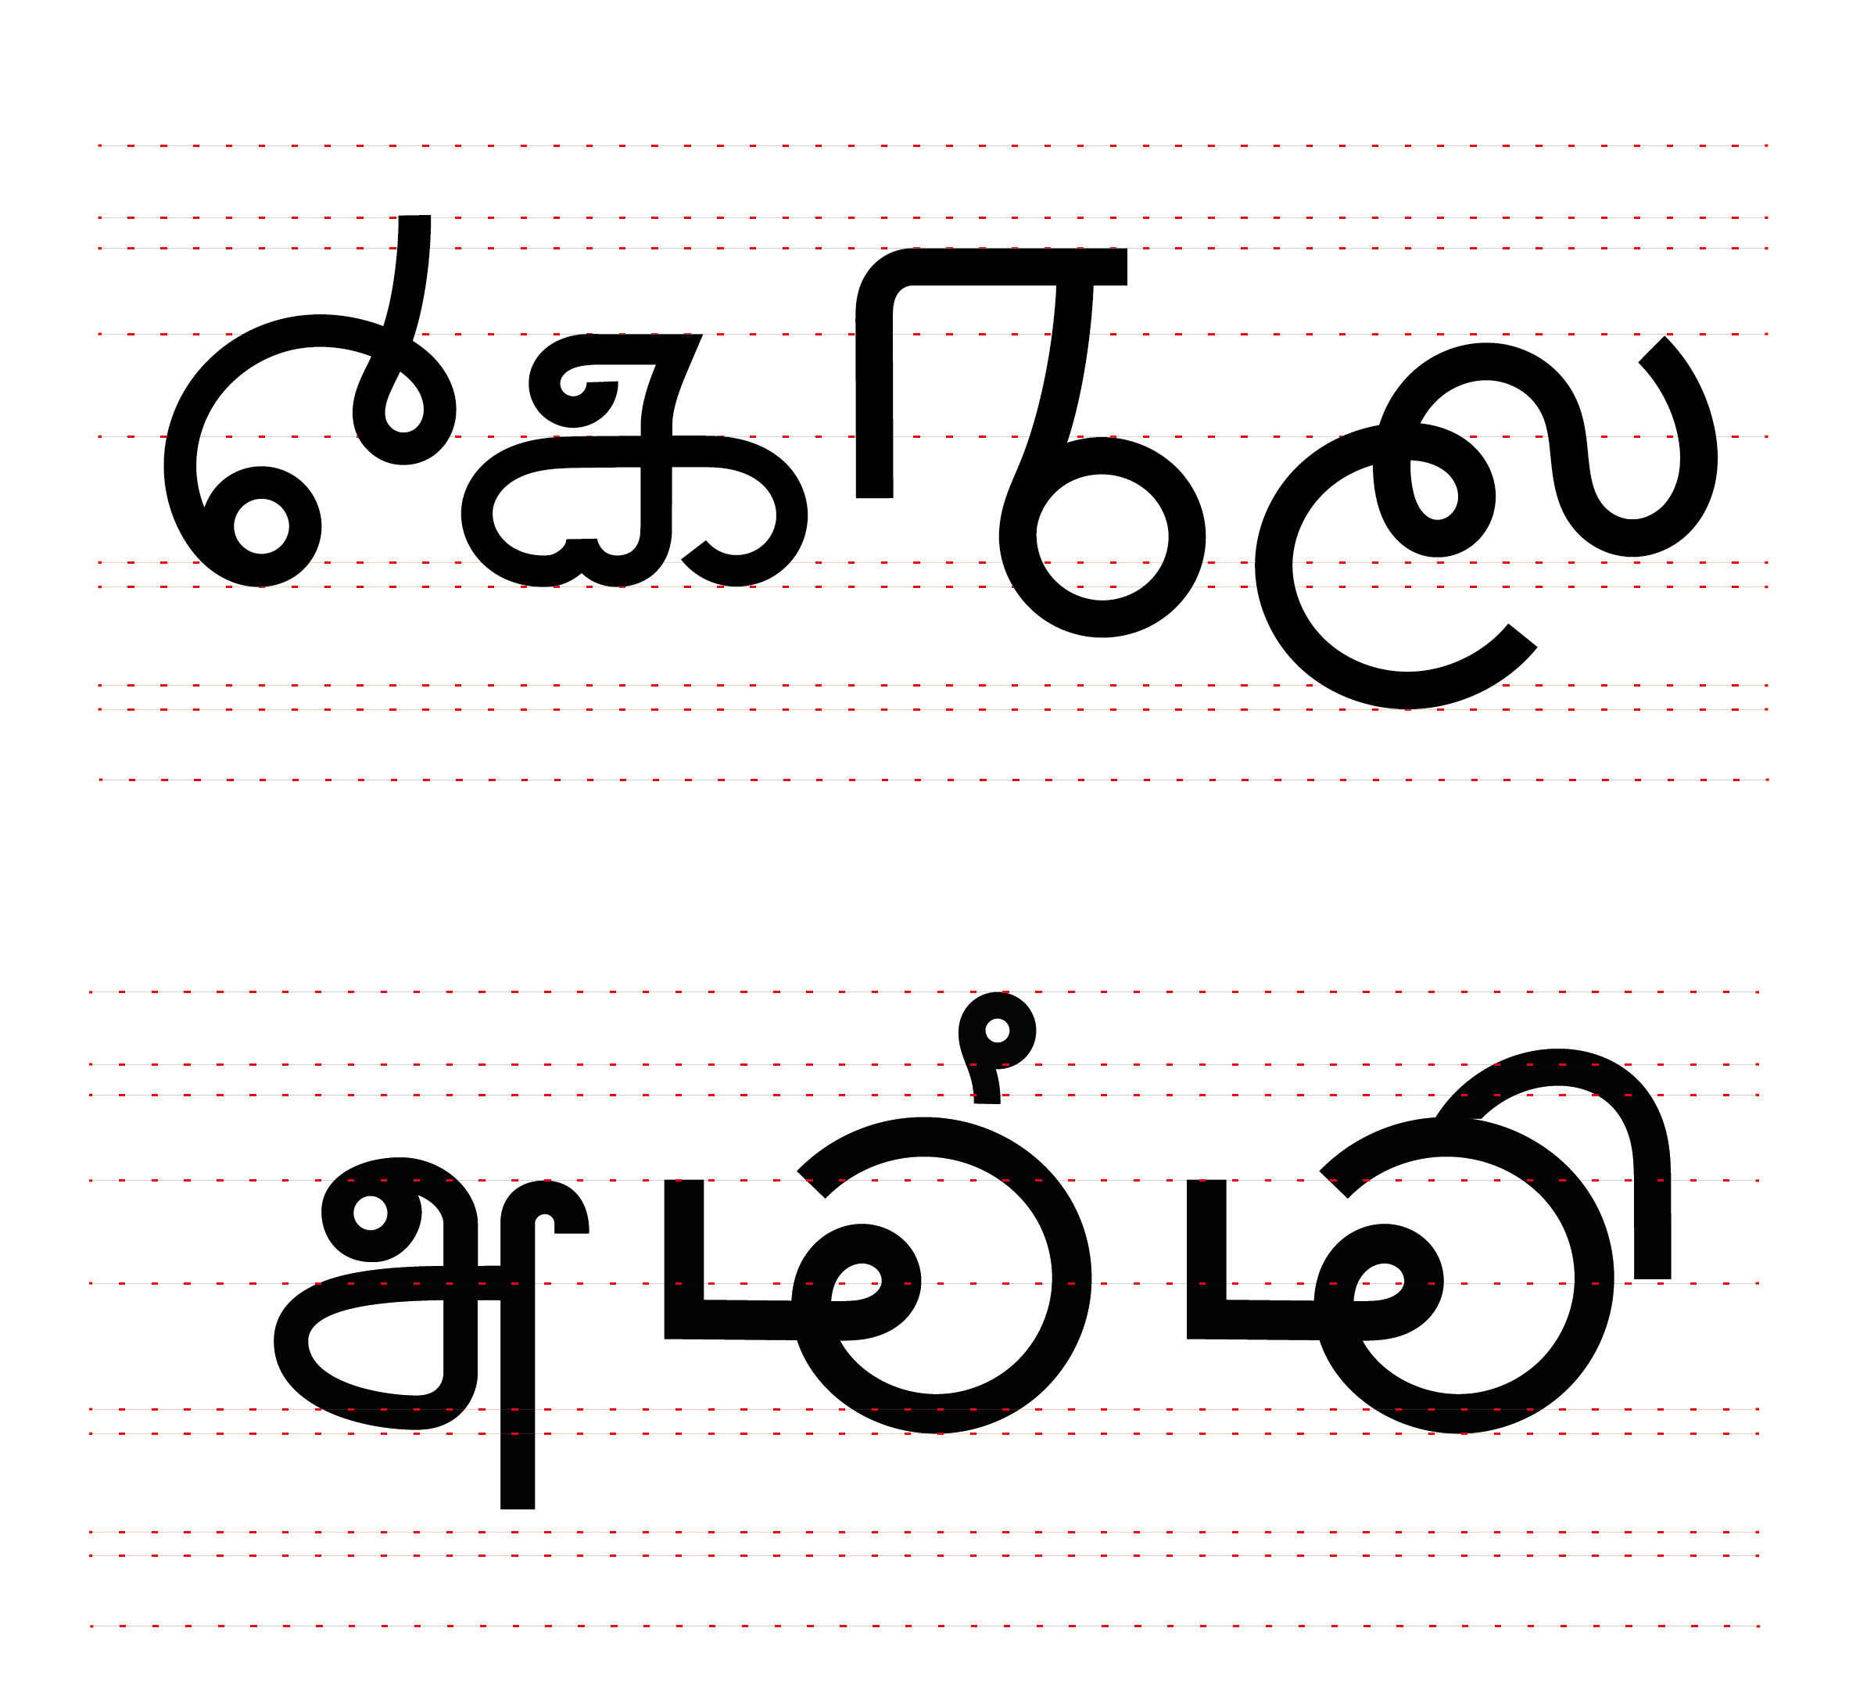

The different

* 1. **Unification of writing systems and diacritics**

Sinhala and Tamil both are abugidas[7] and addition of vowel modifiers (diacritic) has many common aspects. Most of these diacritics have similar visual forms and positioning. Figure XX is using Using the consonant 'k' as an example.

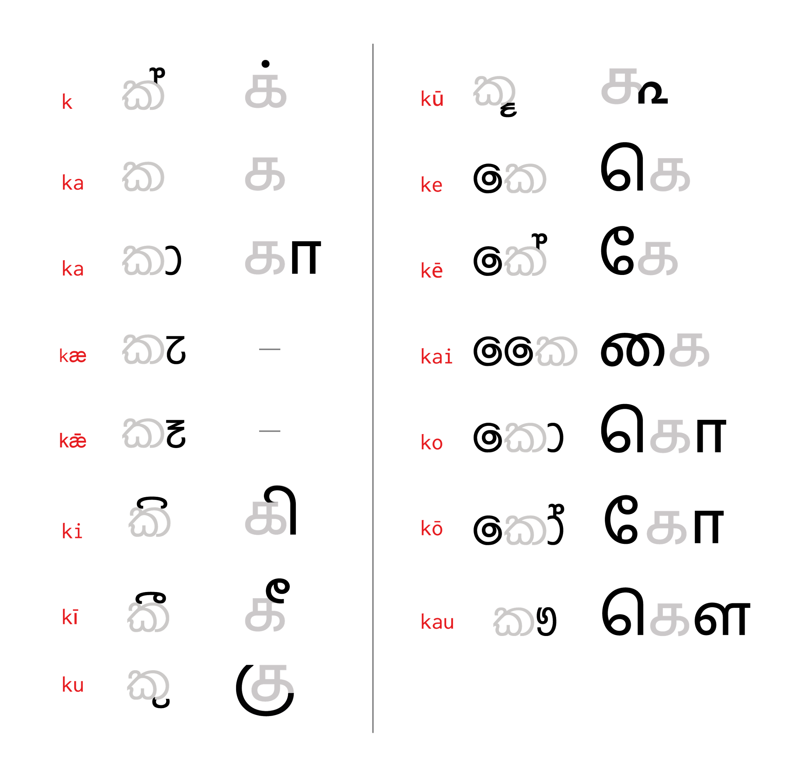

It is evident that the similarities of the writing system

* 1. **Simplifications of alphabets**

Assuming that this new script would be adapted into real life scenarios it was essential to keep the new script simple.

Sinhalese alphabet is divided into two sets, Pure letters(śuddha sinhala ) and Mixed Sinhala (Miśra Sinhala) letters. Although most phonemes of the Sinhalese can be represented by a śuddha letter or by a miśra letter, in standards only of them is considered correct. For example both න and ණ represents the phoneme ‘na’. Tamil also has one-to-many phoneme-grapheme system. Simplification of this systems to a one-to-one phoneme- grapheme assigned system was essential, to make it easy to understand, learn and read.

Various reforms to Sinhala script and language have been suggested aiming to simplify and to make it more accessible. Reforms suggested by Ajith Thilakasena, an award winning author has been followed by many other authors. Although it is far from being actually implemented with reduced number of letters and diacritics and simplified writing system it is the most comprehensive simplified version of SInhala script. This system was used as a benchmark to simplify the system.

1. **Further Applications/ User Cases**

This system script could be only used in scenarios where a Sinhala word and Tamil tamil word share the same meaning and the same pronunciation. For example words ‘අම්මා’ in SInhala and xx in Tamil which means Mother, is pronounced ‘ammā’ in both languages. This system is ideal for signage and wayfinding systems, or to display names.

Figure:

Figure XX presents few type samples developed based on the Other-Letter script, by Pushpananda Ekanayake, a renowned type designer from Sri Lanka. This is an example of how this project could be further developed.

1. **Conclusion**

Sri Lankan community is undergoing a culturally challenging situation where the divide among the different communities is getting wider every day. The language and the script it’s written with is an essential signifier of the culture and people it belongs to. In this experimental project it was explored how typography and design could be practiced to dissolve the ethnic tension in a community.

By combining Sinhala and Tamil letters into a one script, the basic ethnic signifier - language - that defined the divide among the Sinhalese and Tamils was given a new meaning. A true evaluation of this experimental project would be to implement this in a real life situation and to record how people react to it.

**Acknowledgement**

**References**

***Books***

Brass, P. R. 1974. *Language, religion and politics in North India*. London: Cambridge University Press.

GUNASEKERA, R. G. G. O., SAMARASINGHE, S. G., VAMADEVAN, M., & DHARMADĀSA, K. E. O. (1996). *National language policy in Sri Lanka, 1956 to 1996: three studies in its implementation*. Kandy, Sri Lanka, International Centre for Ethnic Studies.

Department of Census and Statistics, Sri Lanka. 2001. *Census of Population and Housing 2001*. [report] Colombo, Sri Lanka: Department of Census and Statistics, Sri Lanka.

Coperahewa, S. and Arunachalam, S. 2002. *Sinhala Bhashave Demala Vacana Akaradiya (A Dictionary of Tamil Words in Sinhala)*. Colombo, Sri Lanka: Godage.

Tilakasēna, A. 1997. *Adata obina basa*. Colombo: Goḍagē saha Sahōdarayō.(Original text in Sinhalese)

Indrasena A. (2001) *Sinhala Alphabet* (Original text in Sinhalese)

Disanayaka J. B. (2000), *Letters and Strokes*, S. Godage

Akuru.org (2001). *Development of Sinhala Characters*. [online] Retrieved from: http://www.akuru.org/developsinhla1.htm [Accessed: 20 Dec 2012].

SInhala Letters

***Journals***

Dharmadasa, K. 1981. Language conflict in Sri Lanka. *Sri Lanka Journal of Social Science*, 4 (2), pp. 47-70. Available at: http://dl.nsf.ac.lk/handle/1/4948 [Accessed: 12 Jan 2014].

Hennayake, S. K. 1989. The peace accord and the Tamils in Sri Lanka. *Asian Survey*, 29 (4), pp. 401--415.

Kearney, R. N. 1978. Language and the rise of Tamil separatism in Sri Lanka. *Asian Survey*, 18 (5), pp. 521--534.

Brown, W. N. 1953. Script reform in modern India, Pakistan, and Ceylon. *Journal of the American Oriental Society*, 73 (1), pp. 1--6.

***Electronic Sources***

Razak, I. 2012. Sri Lanka Ethnic Conflict: Past And Future. [online] 30th June. Available at: https://www.colombotelegraph.com/index.php/sri-lanka-ethnic-conflict-past-and-future/ [Accessed: 15 Jan 2014].

Jayasuriya, R. 2011. Sinhalaisation of the Tamil North amidst increased militarisation. *Trans Currents*, [blog] 4 June 2011, Available at:http://transcurrents.com/news-views/archives/1077 [Accessed: 16 Jan 2014].

Danielson, J. 2013. *The Art and Science of Constructed Scripts*. [video online] Available at: http://www.youtube.com/watch?v=PSL106ZG-v4 [Accessed: 10 Jan 2014].

***Reports***

Social Indicator, Centre for Policy Alternatives - Sri Lanka. 2013. *Top line survey results: Democracy in post-war Sri Lanka*. [report] Colombo, Sri Lanka: Centre for Policy Alternatives - Sri Lanka.

COMMISSION OF INQUIRY ON LESSONS LEARNT AND RECONCILIATION. 2011. *Report of the COMMISSION OF INQUIRY ON LESSONS LEARNT AND RECONCILIATION*. [report] Colombo, Sri Lanka: Presidential Secretariat, Sri Lanka, pp. 308 -309.

1. Social Indicator, Centre for Policy Alternatives - Sri Lanka. 2013. *Top line survey results: Democracy in post-war Sri Lanka*. [report] Colombo, Sri Lanka: Centre for Policy Alternatives - Sri Lanka.
2. There are accusations of attempt to forcefully change the demographic distribution of previously LTTE controlled areas.The resettlement process of the government is focused on avoiding a later uprise of LTTE or Tamil separatism and this (Source - Jayasuriya, R. 2011. Sinhalaisation of the Tamil North amidst increased militarisation. *Trans Currents*, [blog] 4 June 2011, Available at: http://transcurrents.com/news-views/archives/1077 [Accessed: 16 Jan 2014].)
3. A **constructed script** is a new writing system specifically created by an individual or group, rather than having evolved as part of a language or culture like a natural script.
4. jj
5. FM Malithi is a typeface by Pushpanada Ekanayake (isiwara.lk)
6. Kohinoor Tamil is a font-family by The Indian Type Foundry
7. An **abugida** , also called an **alphasyllabary**, is a segmental writing system in which consonant–vowel sequences are written as a unit: each unit is based on a consonant letter, and vowel notation is secondary.